Note For Approval – iText/Apryse PDF Creator

Date | 20/08/2026
Subject | Recommendation for library for creating and editing PDF files
Final Price & Terms | TBD
Preface & Key Points | - iText is a global specialist library for creating and manipulating PDF files in Java and .NET. As a PDF library, iText can be embedded into document solution workflows in industries such as Legal, Finance, Governance, IT, Operations, and more.  - iText’s source code was initially distributed as open source under the Mozilla Public License or the GNU Library General Public License open-source licenses. However, over the years, iText became dual-licensed and is available as open-source (for software is distributed as free) and a commercial license(applicable in our case).  - At Indigo, we started using iText’ open-source code in early 2010s, however, we never graduated to its commercial license model.  - In 2022, iText team reached out to us asking us to compensate them for using their platform for commercial gains
Process followed / Price justification/ Benchmarking | Process followed:  Digital Team had several rounds of internal discussion with legal team and procurement team and it was suggested by legal team that since there is no formal contract or documentation between iText and IndiGo for using this product and since iText already has evidence that IndiGo is using their product without any formal contract, we should settle the past usage by negotiating via procurement team and not wait for any formal litigation or court case.  Basis this, Procurement and Digital team started negotiating the final settlement price with iText and below give 3 commercial options were derived as settlement options  - Settle the Past usage and stop using iText ( where we will give one month of time to remove iText from all your applications )  - $850 K USD settlement amount of iText past usage  - Settlement of Past usage of only iText + Future usage of iText for the 3 years  - $300 K USD per year with no past usage charges for a three-year contract, with no termination clause since this is being already used for few years now within Indigo  - iText Enterprise license + Apryse Stack ( Base Package + any 3 add-ons that can be decided during implementation of the license for 5 applications will be  - $350 K USD per year Waiving of fee for the Complete past usage (0 USD ) . Termination Clause will be applicable after two years only, so minimum payout will be $700 K USD
Price justification | iText is deeply ingrained in varied applications within Indigo’s ecosystem – some key use-cases are as follows:  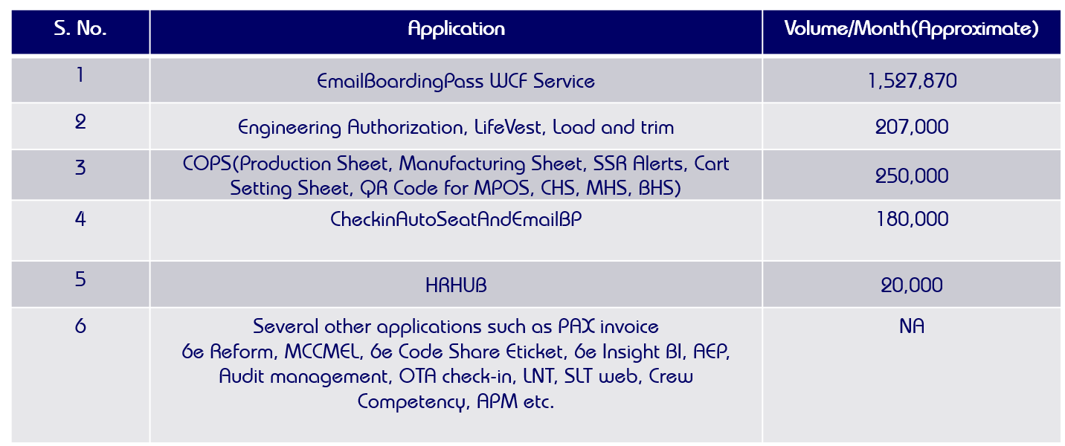  By continuing to work with iText we will incur no cost and effort for migrating all the key applications to the newer PDF tool. In addition, to that we are likely to get charged for all the past usage by iText. By opting for no cost for past usage commercial model, we will get access to iText large PDF toolkit which will provide us a complete line of Apryse products comprising the open-source iText Core PDF library and its add-ons
Recommendation | iText PDF Creator and Editor is the required tool for generating all PDF related documents such as Boarding Pass, Engineering Authorizations, Lifevest, Load and Trim, PAX Invoice etc. (Volume Numbers shared above)  In light of the above, we would recommend adoption of Option 3 which is Settlement of Past Usage for iText SDK + Future Usage of Entire Apryse stack  It will include continuation of iText on all the existing applications within IndiGo Domain. It will also allow usage of Apryse stack with the below future for unlimited usage for up to any 5 applications.  iText Enterprise license + Apryse Stack ( Base Package + any 3 add-ons that can be decided during implementation of the license for 5 applications)  - $350 K USD per year - Waiving of fee for the Complete past usage (0 USD ) . Termination Clause will be applicable after two years only, so minimum payout will be $700 K USD
Prepared By | ------------------  (Mayank Tyagi )
Reviewed By | ------------------ ------------------  (Charu Verma) (Ravideep Singh)
Approved By | ------------------ ------------------ ------------------  (Sanjay Jha) (Neetan Chopra) (Vineet Mittal)

